Table of Contents

1. Background Research and Literature Research 2
Project Aim 2
Objectives 2
Background Research 2
Literature Review and Critique of Existing Solutions 2
2. Summary of Progress to Date 3
Literature Review 3
Data Acquisition and Preprocessing 9
Risk Metric Definition ( Target Column Creation) 10
Exploratory Data Analysis (EDA) 10
Initial Model Implementation and Evaluation 11
Imbalance Handling 12
Project Management and Challenges 13
3. Consideration of Ethical, Legal, Professional, and Social Issues 13
Ethical Considerations 13
Legal and Professional Compliance 14
Social Impact 14
4. Project Plan 14
Project Methodology 14
Project Scope and Risk Management 14
Task Completed, Remaining, and Deliverables 15
Quality Evaluation and Project Value 15
5. Level of the Project 17
6. References 18

Figures and Tables

Figure 1 : Handling Missing Values 11
Figure 2 : Encoding of the Categorical Values 11
Figure 3:Creation of Risk Column 12
Figure 4: Variable distribution among categories 12
Figure 5: Day indoors vs Social Weakness 12
Figure 6: Mood Swing vs Coping Struggles 13
Figure 7:Gradient Boosting Implementation 14
Figure 8: Smote Implication 14
Figure 9: Data Distribution after Imbalance Handling 15
Figure 10: Gantt Chart for Project Management 18

Table 1 : Comparision of Models and Parameters of Related Research Papers 5
Table 2: Comparision of Initial Models 13
Table 3: Project Deliverables and Timeline 17

1. Background Research and Literature Research

Project Aim
The principal purpose of the project is to investigate the impact and depth of various indicators of mental health, such as psychological and behavioural features (e.g., mood swings, coping struggles, growing stress) and demographic or lifestyle factors (e.g., location, age, day spent indoors) by focusing on feature importance using techniques such as Explainable A.I. methods. The project's goal is also to predict mental health risk levels (low, medium, high) among individuals from diverse backgrounds, utilizing infrequently used machine learning algorithms to assess their potential. An additional goal of the project is to build a Streamlit interface that provides users with an interactive platform, allowing them to grasp the model's insights and interpret the model's predictions.

Objectives
Data Preprocessing and Target Integrity: To ensure the raw data is clean and is in a usable format for the algorithms to be trained and to create a non-deterministic Target Column consisting of multiple Classes (Low, Medium, High Risk), implementing a structured logic ensuring models focus on the patterns instead of identifying the logic.
Imbalance Handling: To resolve the imbalance present in data classes, implement SMOTE(Synthetic Minority Over-sampling) techniques and alternative class balancing methods to ensure each class is focused upon and concentrated accordingly.
Advanced Model Optimization: To implement and evaluate, and fine-tune several advanced models (CatBoost, LightGBM, BRFC, and Stacked Ensembles) that are infrequent in the mental health analysis industry, with high possibilities of examining if they outperform the conventional models.
Scientific Discovery (Feature Importance): To utilize Explainable A.I. methods (SHAP values) to identify which features dominate the prediction of the models and rank them accordingly.
Performance Measurement and Evaluation: To conduct measurement of performance using metrics including Recall, Precision, and AUC, ensuring that the project meets the threshold, and also to compare the results with the previous similar studies.
Installation and Explanation: To build a Streamlit Interface on the final preferred model, demonstrating a real-time prediction and explaining the top indicators.
Documentation and Reporting: To complete and submit the required project documentation with the inclusion of IPR and FPR to ensure that all the methodologies and procedures are recorded professionally and academically.

Background Research
The project is driven by the fundamental idea that mental health issues are not just an individual obstacle but also a global challenge, as poor mental health condition burdens someone from reaching their true potential, and the continuous lack not only significantly decreases a person's confidence but can affect the surrounding personalities as well. An estimated amount of US$1 trillion per year is lost in productivity every year due to the presence of anxiety and depression in the workplace ((WHO), 2025).The situation gets worse when social stigma and fear around seeking help kick in and create a barrier for early diagnosis for individuals. Only around 9% of the people with depression globally receive appropriate treatment (HOPE, 2024).This generates the need for accessible screening tools that are non-clinical to ensure a person can grow confidence to seek mental health treatment.

The necessity for an early, accessible screening interface, therefore, faces the challenge of the complexity of risk indicators. The risk for mental health-related scenarios is often caused by a combination of genetic, environmental, and psychiatric factors rather than a single cause. Therefore, any predictive model working on the mental health objectives needs to understand the importance of each determinant, including demographic(age, gender), behavioural (days_spent_indoors), and psychological (mood swings, coping struggles) indicators. Feature Importance, therefore, plays an influential role in these predictive machine learning models, which can be justified by the theoretical background, such as the Biopsychosocial model, which points out the interconnection between biological, psychological, and social determinants shaping a person's mental health status. By capturing how these interconnected indicators contribute to mental health risk level, the project attempts to develop an effective, explainable, and accurate model.

Literature Review and Critique of Existing Solutions
One pattern that is consistent in the majority of the studies conducted on mental health based on machine learning is the reliance on binary classification. The studies of (Laijawala, et al., 2020) and (Retnaswamy, et al., 2025) successfully applied machine learning models to predict the outcome of mental health problems. However, their studies were limited to simple Yes/No responses for the treatment of these complications. While the binary classification is useful in initial assessments, the approach oversimplifies the spectrum and range of mental health risk levels, which often exist in a continuum of severity from low to high. The project builds on the multi-class target solution following the similar methodologies established by (Nagaraj, et al., 2023). This study established a Multi-Class Severity Index for mental which is a more reliable approach to address the gap present in the predictive models that only focus on binary outcomes.

The selection process of machine learning algorithms for this project is influenced by the demonstration of handling complicated datasets efficiently by the ensemble learning techniques in mental health prediction. Several studies have successfully proven the effectiveness of these ensemble methods, particularly Gradient Boosting Models (GBM), in predicting mental health outcomes. (Xin, et al., 2025) showed that XGBoost, a member of the Gradient Boosting family, outperformed the conventional algorithms when predicting outcomes like stress and depression. Therefore, the project plans to implement other advanced forms of the Gradient Boosting Algorithm, which include CatBoost and LightGBM, for their capability to handle large, complex datasets and deliver fast prediction efficiency.

In a study, (Chung & Teo, 2023) implemented a Voting Classifier ensemble model that was unsuccessful at beating the Gradient Boosting model when it comes to prediction accuracy. Therefore, an advanced Stacked Ensemble Model using hybrid learning could be an optimal solution, which is specifically designed to outperform the simple ensemble both in terms of precision and robustness, and the project plans to implement this methodology.
Practical Research and Resolving Technical Challenges
The initial problem of class imbalance is often ignored, and therefore, the model shows poor performance even if a strong pattern exists within the variables for prediction. Although some models have class weight parameters, the parameter is not native to all the algorithms. To handle the class imbalance, the project plans to implement SMOTE(Synthetic Minority Oversampling Technique).

Many Algorithms have their own feature importance analysis method, but to implement on a global scale, Explainable AI (XAI) methods are really efficient, and the project plans to use SHAP values to interpret the model predictions. SHAP values break down the model’s prediction into individual features, ensuring transparency and interpretability. To ensure that the model learns patterns, not logic, the target variable will be created using variables that don’t need the study of their impact on mental health risk levels. This will ensure the models trained on the dataset will focus on analysing symptoms and patterns rather the learning internal logic.

2. Summary of Progress to Date
The Project has already accomplished the preliminary stages, including literature review, initial model implementation, dataset preparation, target column creation, and data imbalance handling, aligning with the project’s core objectives to predict mental health risk levels, along with providing a user interface to demonstrate interpretability.

Literature Review
A thorough, detailed review of 15 research papers relevant to my project field was conducted, concentrating on the machine learning algorithm and the hyperparameters that were used to achieve the outcome. The table summarising the findings was created to provide a strong foundation to back the decision of implementing advanced Gradient Boosting Techniques such as CatBoost and LightGBM. Additionally, the requirement of Explainable AI (XAI) methods was identified from the insights of the findings.
Table 1 : Comparision of Models and Parameters of Related Research Papers
Title | Author | Dataset | Models Used | Best Model | Optimized parameters for Best Model | Imbalance Handling | Best Model Results
Mental Health Prediction using Data Mining: A Systematic Review | (Laijawala, et al., 2020) | OSMI Survey | Random Forest, Decision Tree, Logistical Regression, OneR, Naïve Bayes, NNge | Decision Tree | Not Mentioned | Not Explicitly Stated | Accuracy: 82.2%
Mental Health Prediction Models Using Machine Learning in Higher Education Institution | (Mutalib, et al., 2021) | Survey data from a higher educational Institute and DASS-21 and WHOQOL segments | Decision Tree, Neural Network (MLP), Support Vector Machine, Naïve Bayes, Logistic Regression | SVM (Depression) | Not Mentioned | Not Explicitly Stated | Accuracy: 88.15%
Machine learning-based analysis and prediction of factors influencing mental health among children and adolescents in Jiangsu Province | (Xin, et al., 2025) | Surveillance project based on Common diseases present among student in Jiangsu Province | Decision Tree, Naive Bayes, Random Forest, K-Nearest Neighbours, XGBoost | XGBoost | η=0.3, max_depth=6, nrounds=100, early_stopping_rounds=10, verbose=1 | Missing Categorical values were handled using ‘mice’ package | AUC: Depression (0.799)
Mental Health Treatment Prediction Using Machine Learning | (Retnaswamy, et al., 2025) | Survery Dataset from Kaggle | Logistic Regression, K-Nearest Neighbours, Random Forest | Random Forest | Not Mentioned | Not Explicitly Stated | Accuracy: 81.2%
Machine learning-based predictive modelling of mental health in Rwandan Youth | (Ndikumana, et al., 2025) | Rwanda Mental Health Survey (2018) | Logistic Regression, Support Vector Machine, Random Forest, Gradient Boosting | Random Forest | max_depth=10, min_samples_leaf=1, min_samples_split=2, n_estimators=200 | Data was a little imbalanced, but no method applied to handle it | Accuracy: 88.80%
Detection of child depression using machine learning methods | (Haque, et al., 2021) | Survey on Mental Health and Wellbeing on 2nd Australian Child and adolescent (2013-2014) | Random Forest, XGBoost, Decision Tree, Gaussian Naive Bayes | Random Forest | Not mentioned | Oversampling and Class weight was applied to handle the imbalance | Accuracy: 95%
Mental Health Prediction using Machine Learning Models and Large Language Model | (Kamoji, et al., 2024) | A comprehensive survey (41000 samples) | SVM, Logistic Regression, Random Forest, Bagging, Ada-Boosting, Max Voting Technique (Ensemble) | Random Forest | Not mentioned | Not Explicitly Stated | Accuracy: 99%
Comparative Analysis for Prediction and Classification of Mental Health Issues and Challenges Using Hybrid Learning Techniques | (Nagaraj, et al., 2023) | Available Dataset from Online | Random Forest, Support Vector Machine, K-Nearest Neighbour, Decision Tree, Deep Learning, Hybrid Ensemble models | Hybrid Ensemble models | Not Mentioned | Not Explicitly Stated | Result was not mentioned (Comparative Study)
Single classifier vs. ensemble machine learning approaches for mental health prediction | (Chung & Teo, 2023) | OSMI survey  (2014) | Logistic Regression, Gradient Boosting, Neural Networks, KNN, SVM, Voting Classifier, Deep Neural Networks, Extreme Gradient Boosting | Gradient Boosting | Estimators=1000, learning rate=0.0001, max depth=17, min_samples_split=10, min_samples_leaf=5, sub-sample=0.5, loss=exponential | No method used to handle imbalance, but K-fold was mentioned to get better results | Accuracy: 88.80%
Comparative Analysis of Machine Learning Techniques for Mental Health Prediction | (Paul & Juliet, 2023) | Self-Reported Dataset | Logistic Regression, K-Nearest Neighbour, Decision Tree, Random Forest | Random Forest | Not mentioned | Not Explicitly Stated but parameter tuning was performed | Accuracy: 81.00%
Review of Machine Learning Algorithms for Diagnosing Mental Illness | (Cho, et al., 2019) | Multiple Datasets from various studies | Support Vector Machines, Gradient Boosting, Random Forest, Naïve Bayes, K-Nearest Neighbours | Random Forest and SVM majorly | Not mentioned | Not Explicitly Stated | Comparative study summarizing other literatures
Prediction of Depression via Supervised Learning Models: Performance Comparison and Analysis | (Sabouri, et al., 2023) | Depression dataset from Kaggle | K-Nearest Neighbour, Random Forest, Logistic Regression, Decision Tree , Support Vector Machine, Naive Bayes | Logistic Regression and SVM | Not Mentioned | SMOTE was used to handle Imbalanced data | Accuracy: 83.32%
A Model-Mediated Stacked Ensemble Approach for Depression Prediction Among Professionals | (Ahmmed, et al., 2025) | Depression based dataset from Kaggle in professionals | K-Nearest Neighbours, Support Vector Machine, Multi-Layer Perceptron, AdaBoost, Logistic Regression, Gradient Boosting, Naïve Bayes, Stacking Ensemble | Stacking Ensemble (Logistic Regression as the meta classifier) | Not Mentioned | Dataset was balanced | Accuracy: 98.75%
Machine-learning-based cost prediction models for inpatients with mental disorders in China | (Ma, et al., 2025). | Dataset made from 46 hospitals in Jinhua | Generalized Linear Regression, LASSO regression, Support Vector Regression, CART, XGBoost, Random Forest | Random Forest | max_depth=10, max_features=5, min_samples_leaf=3, n_estimators=45 | Logarithmic transformation Used to handle skew data
Multi-Class Adaptive Active Learning for Predicting Student Anxiety | (Almadhor, et al., 2024) | Student anxiety Dataset from Kaggle and a secondary dataset | K-Nearest Neighbours , Logistic Regression, XGBoost , Naive Bayes , Random Forest , Decision Tree | Random Forest | Not mentioned | Not explicitly stated | Accuracy: 83.00% on secondary dataset

Data Acquisition and Preprocessing
The dataset, consisting of 292364 entries across 17 variables, was preprocessed properly by first reducing the duplicates using the Pandas library. The process reduced the dataset size to 290051 records. Only the ‘self-employed’ column had null values, which were converted to ‘No’ to match the majority class and to prevent the loss of information. All categorical Features were converted to numerical columns for the purpose of making the dataset more suitable for the machine learning algorithms. Ordinal Encoding, Binary Encoding, and One-Hot encoding were all implemented accordingly based on the feature structure. The process expanded the feature set to 53 columns.
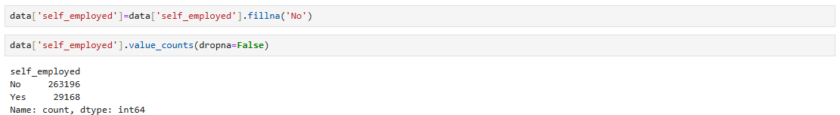
Figure 1 : Handling Missing Values
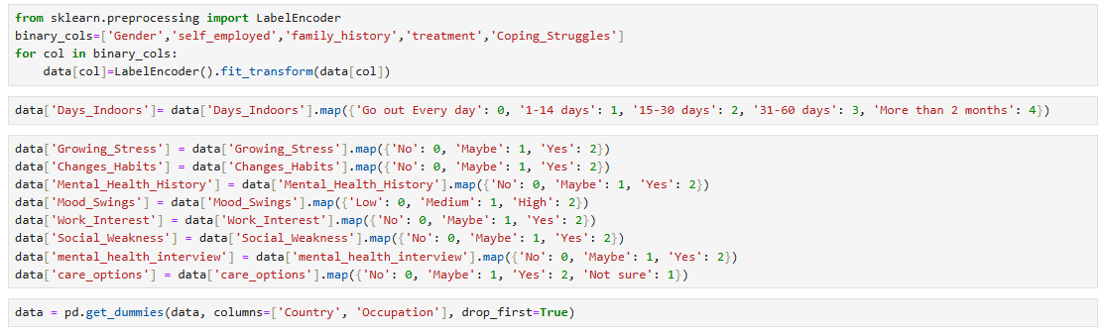
Figure 2 : Encoding of the Categorical Values

Risk Metric Definition ( Target Column Creation)
The target column Risk Level was created in order to categorize individuals into the different levels of risk derived from a few suitable sets of indicators. The treatment, mood swings, and mental health history indicators were used to derive a logic to create the new target column consisting of 160276 high, 112509 medium, and 17266 low classes, suggesting the need to handle the imbalance.
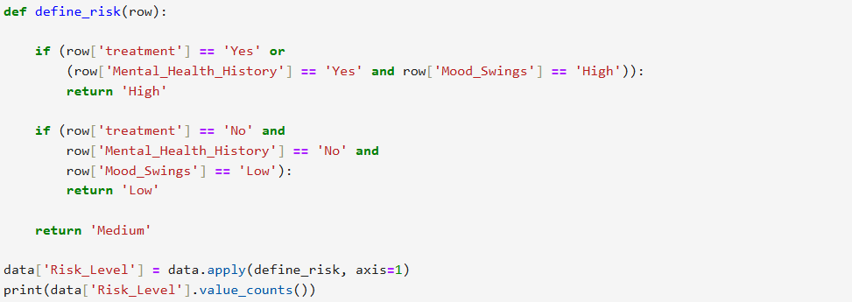
Figure 3:Creation of Risk Column

Exploratory Data Analysis (EDA)
Primary EDA was handled using the popular Seaborn and Matplotlib libraries to grasp the feature distribution and initial correlations between features. Some small associations between features were observed, but nothing severe enough to conclude.
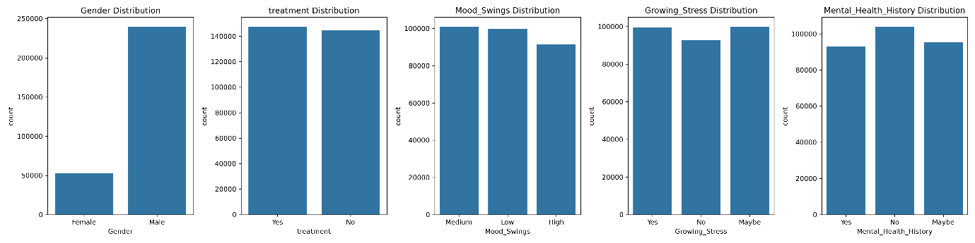
Figure 4: Variable distribution among categories
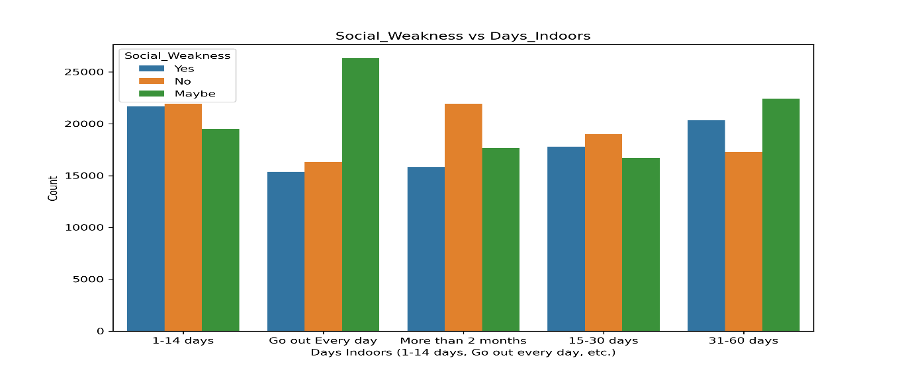
Figure 5: Day indoors vs Social Weakness
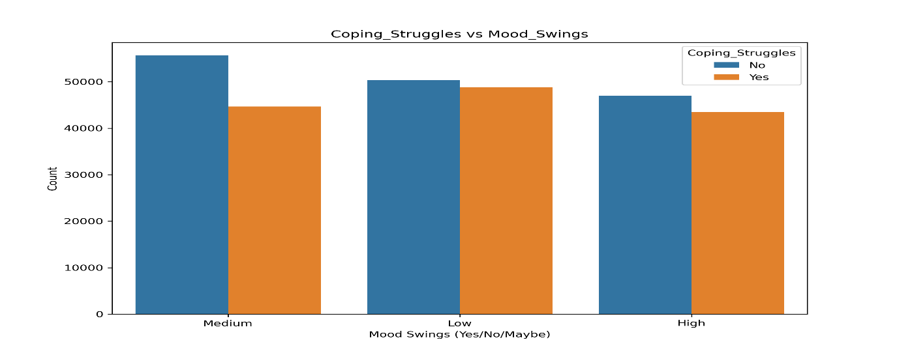
Figure 6: Mood Swing vs Coping Struggles

Initial Model Implementation and Evaluation
Random Forest, AdaBoost, and Gradient Boost were implemented as Initial prototype Models to later compare their results with advanced models from the same family, such as CatBoost and LightGBM, later on. The simple models provide a starting point for the analysis of the more advanced machine learning implications. The following table shows the comparison of the four initial models that have been tested as a baseline for the more advanced boosting algorithms.
Table 2: Comparision of Initial Models
Model | Weighted Average F1-score | Low Risk Recall | Overall Accuracy
Random Forest | 0.73 | 0.89 | 73%
AdaBoost | 0.61 | 0.00 | 62%
Gradient Boosting | 0.75 | 0.90 | 75%
XGBoost | 0.76 | 0.90 | 76%

The image below is a demonstration of how the Boosting (Gradient Boosting) models were implemented
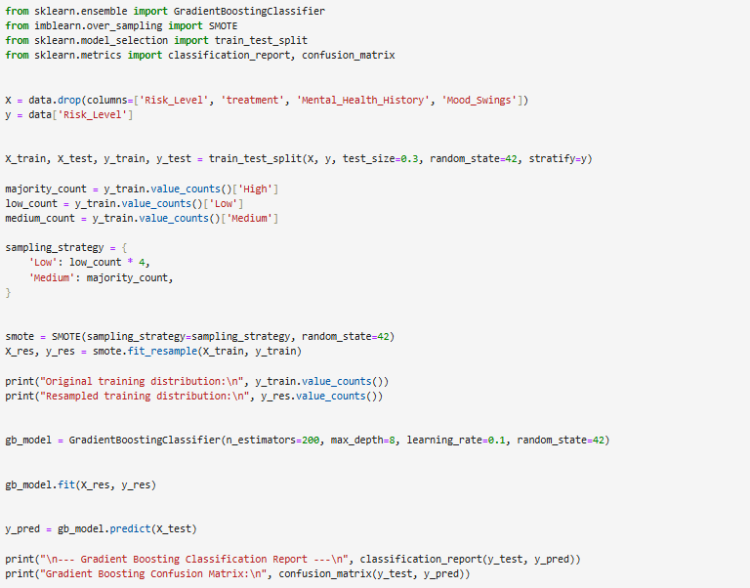
Figure 7:Gradient Boosting Implementation

Imbalance Handling
Target Class Imbalance was handled properly using SMOTE to oversample the low minority class. An appropriate sampling strategy was implied, resulting in the low class increasing four times from the previous state, with 48344 samples.
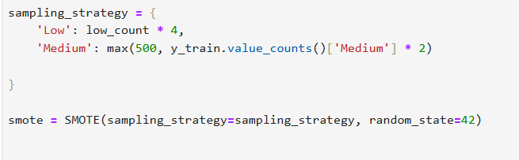
Figure 8: Smote Implication
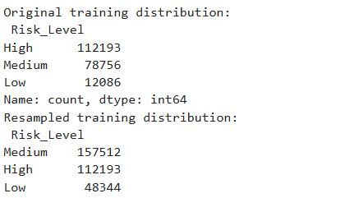
Figure 9: Data Distribution after Imbalance Handling

Project Management and Challenges
The project is currently being conducted using a data-driven approach and agile methodology, allowing for work to be informed by immediate feedback. The Primary Challenges being faced are the class imbalance. The introduction of SMOTE generates significant noise, which does not generalize well for the test, especially in the case of AdaBoost. The project plans to switch from data-level resampling to an algorithm-based solution implementing CatBoost and LightGBM with their dedicated scale_pos_weight or class_weight parameters.

3. Consideration of Ethical, Legal, Professional, and Social Issues
In any form of research, especially one centered around mental health, using personal and sensitive data must address a variety of ethical, legal, professional, and social considerations before stepping forward. The project is mainly built upon the publicly available data, the Mental Health Dataset by Bhavik Jikadara, which is accessible through Kaggle.

Ethical Considerations
The data is anonymized and non-identifiable, ensuring the ethical risks are next to zero. However, to comply with the ethical standards, the requirement of data handling without manipulation and with transparency is necessary. Personal Identifiable Information (PII), which includes names, emails, and addresses, was not used in handling the dataset. Despite that, the dataset does work around sensitive data, such as coping struggles, mental health history, and family history. The project ensures these data and data similar to that are handled with utmost care to certain privacy and confidentiality. The ethical considerations of algorithmic bias are still present as the dataset is imbalanced, resulting in the models being less accurate towards the underrepresented groups. The deployment of the project, therefore, might worsen the inequality by introducing bias in judging certain groups. To meet the ethical requirements fairness of the models must be examined at all costs. The project will also implement SMOTE and a data balancing strategy to mitigate the bias.

Legal and Professional Compliance
The project is being conducted in accordance with relevant data protection laws, which include the UK’s General Data Protection Regulation (UK GDPR). The data doesn’t consist of any personal identifiers, and the project solely focuses on academic and non-commercial purposes. Privacy protection is the top priority of the project, and any measurements concluded in the project will ensure confidentiality, as none of the data will be processed beyond the scope of this project.

To meet the professional standards, the project will conform to the guidelines outlined by organizations such as the British Computer Society (BCS) and will try to abide by other relevant codes of conduct present in the data science field. The project will ensure that the full transparency of data is provided, results are presented fairly, and plagiarism is strictly avoided. Explainable AI (XAI) methods used in the model will try to make the model’s predictions more interpretable in order to gain user trust.

Social Impact
The main objective of the project is to provide a system that is accurate in predicting and is respectful towards all groups of personalities. A successful implication has the possibility to improve accessibility, address the global treatment gap, and provide a screening tool that is cost-effective. The project will ensure that any discriminatory practices are avoided by regular checking to make certain predictions are not skewed by irrelevant features. The final project will be a supporting tool that will enable people to understand their mental health risk without judgment and will encourage them to seek a diagnosis in a safe manner. The project will enable Explainable AI (SHAP values) methods to establish trust among diverse users, ensuring they are not marginalised by the predictions.

4. Project Plan

Project Methodology

The project is currently utilising a hybrid waterfall-agile methodology to achieve both the final goal and objectives at each stage. The initial stages (project selection, data collection, project proposal submission, data preprocessing, exploratory data analysis) were phrased by the waterfall strategy and were conducted in sequence. The next phases (model development, model testing, model evaluation) will be conducted using an agile strategy, dividing the workload into sprints and gaining continuous improvement based on testing results and feedback.

Project Scope and Risk Management
The project’s scope to create a multi-level mental health prediction system is fixed to deliver the final deliverables promptly, adhering to the academic requirement. However, the project is still flexible for adjustments based on the model’s performance and insights gained from data analysis. The project is organized to deliver a few timely objectives at each stage, better detailed in the Gantt chart below. The main resources of the project are generally technological, which include the resources for conducting model training, such as Python, Jupyter Notebooks, and a model environment etc. The project’s current risk management strategy is focused on adjusting to an alternative solution ( switching to model model-based parameter to handle imbalance to avoid the flaws of SMOTE) allows the project to reach goals without wasting time.

Task Completed, Remaining, and Deliverables
The project has completed all the fundamental and initial tasks and is now stepping towards the advanced model optimization and final submission.
Table 3: Project Deliverables and Timeline
Description | Status | Completion Date | Deliverables
Initial Project Idea Submission | Done | Oct 10, 2025 | Initial Project Idea Quiz
Detailed Project Proposal Submission | Done | Oct 10, 2025 | Detailed Project Proposal Form Submission
Data Collection and Initial Literature Review | Done | Oct 8, 2025 | Research Paper Table
Data Cleaning and Preprocessing | Done | Oct 9, 2025 | Cleaned Dataset
Feature Encoding | Done | Oct 13, 2025 | Encoded Dataset ready for model training
Expletory Data Analysis (EDA) and Target Variable Creation | Done | Oct 14, 2025 | Key Visualizations to understand relationships between variables
Baseline Model Training and Evaluation (RF/Adaboost) | Done | Oct 20, 2025 | Baseline model report
Implement and Tuning CatBoost | To Do | Oct 31,2025 | Optimised CatBoost model with classification report
Implementing and Tuning LightGBM | To Do | Nov 7,2025 | Optimised LightGBM model with classfication
Final Model Selection and Architecture Documentaion | To Do | Nov 10,2025 | Final Model selection through stacking ensemble and classification report
Explainable AI analysis | To Do | Nov 14,2025 | XAI visualization and interpretability report
Streamlit Interface Creation and Integration | To Do | Nov 28,2025 | A Deployable interactive interface
Drafting Final Report and Review | To Do | Dec 1,2025 | Draft FPR submission
Final Review and Submission | To Do | Dec 8,2025 | Final FPR submission
Refining The overall Project and Adjustments | To Do | Dec 27,2025 | Adjusted and refined Project showcase
Presentation Demonstration | To Do | Jan 16,2026 | Demonstration materials

The following Gantt chart will visually demonstrate the project timeline mentioned above which integrates waterfall methodology with agile modelling and reporting sprints.

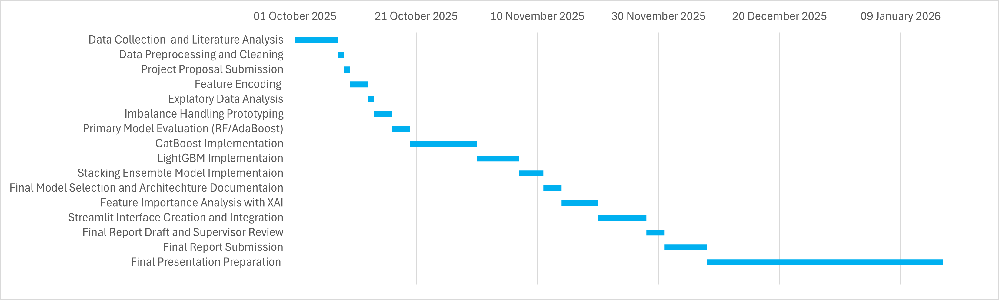
Figure 10: Gantt Chart for Project Management

Quality Evaluation and Project Value
The performance of the project will be evaluated through metrics such as accuracy, precision, recall, and F1-score. The interpretability will be achieved by both models’ built-in feature importance and SHAP values, ensuring clarity. User experience will be measured through regular usability testing of the Streamlit Interface, ensuring the users have ease in interacting with the platform. Cross-validation and Supervisor Feedback will ensure the project’s robustness, and class imbalance will be addressed through both SMOTE and in-built algorithmic features. The progress of the project will be monitored through a Gantt chart to ensure that the progress is in sync with the timeline. The project value will be assessed through the practical implications of the mental health predictions and the academic contribution in applying machine learning in mental health research with explainable AI.

5. Level of the Project
The project addresses the complexity of the challenge that naturally arises when using machine learning to predict mental health risk levels. The challenge is complex and highly relevant at the same time, as mental health analysis has both high societal and scientific significance. Handling Mental health prediction requires working with multidimensional psychological and behavioral data that automatically involves noise, class imbalance, and little to minimal correlations. From an academic point of view, the task is appropriate for an MSc-level project as the successful implementation requires not only accurate model training but also proper evaluation, interpretability, and user-friendly interface development before deployment. The challenge becomes more complicated as the creation of the distinctive multi-class target column needs a reliable classification logic that still allows for the interpretation of the feature contributions. The project heavily aligns with my career goals in data science and analytics in the health care industry, as the project integrates algorithmic complexity with real-life applications, assessing mental health risk.
The artefact that the project is developing involves creating a predictive machine learning model that has the classification ability to distinguish between low, medium and high-risk categories, focusing upon mental health-based indicators present in the dataset. The project will primarily utilise higher members of the boosting algorithm family, such as CatBoost and LightGBM, to deal with complex, highly complex, and imbalanced datasets and still provide accurate and precise predictions. In Addition, the model will introduce an interactive Streamlit-based interface, ensuring accessibility for users who find non-clinical early diagnosis superior, and will enable them to use and interpret real-time mental health predictions. The project diverges from other existing traditional solutions for mental health predictions with the introduction of a stacked ensemble method integrating with model interpretable tools such as Explainable AI (SHAP values), creating a more transparent user user-friendly tool which is often ignored by the existing non-transparent binary prediction models. The incorporation of advanced machine learning algorithms with a user-centric interface design promotes accessibility, fair assessment, and user empowerment.
The project achieves more depth by going beyond the simple classification through the investigation of complex relationships between psychological, demographic, and behavioural features, demonstrating a combination of theoretical can practical dimensions as the Biopsychosocial model links biological, psychological, and social indicators in assessing mental health. Strict testing and validation are embedded in the project continuity, as cross-validation will ensure the model generalizes well, and evaluation metrics such as precision, recall, and F1-score will deal with the measurement of performance across all risk levels, including underrepresented classes. This aggregation of theory-practical hybrid design illustrates the project has a comprehensive and scholarly approach required for a master's project.
Finally, the choice of methodologies and the models can be clearly justified as Catboost and LightGBM are designed to handle large nonlinear datasets, even with the presence of imbalance, which other conventional prototype models often fail to do. At the same time stacked ensemble method combines the strengths of each model to achieve reliability. The choice of SHAP value is due to its superiority to other feature importance methods, as it is not only accurate, precise, but can also provide a locally specific explanation of how a model can conclude a prediction based on individual feature importance.
Therefore, the project exhibits MSc-level depth, engagement, and rigor by tackling a real-world global problem with advanced machine learning algorithms for prediction, interpretable outputs for understanding, and a user-friendly interface to achieve accessibility.

6. References

(WHO), W. H. O., 2025. Over a billion people living with mental health conditions – services require urgent scale-up. [Online]
Available at: https://www.who.int/news/item/02-09-2025-over-a-billion-people-living-with-mental-health-conditions-services-require-urgent-scale-up
[Accessed October 2025].
Ahmmed, M. M. et al., 2025. A Model-Mediated Stacked Ensemble Approach for Depression Prediction Among Professionals. arXiv preprint.
Almadhor, A. et al., 2024. Multi-Class Adaptive Active Learning for Predicting Student Anxiety. IEEE Access, Volume 12.
Cho, G. et al., 2019. Review of Machine Learning Algorithms for Diagnosing Mental Illness. Psychiatry Investigation, 16(4), pp. 262-269.
Chung, J. & Teo, J., 2023. Single classifier vs. ensemble machine learning approaches for mental health prediction. Brain Informatics, Volume 10.
Haque, U. M., Kabir, E. & Khanam, R., 2021. Detection of child depression using machine learning methods. PLOS ONE, Volume 16.
HOPE, P., 2024. The Global Mental Health Crisis: 10 Numbers to Note. [Online]
Available at: https://www.projecthope.org/news-stories/story/the-global-mental-health-crisis-10-numbers-to-note/
[Accessed October 2025].
Kamoji, S. et al., 2024. Mental Health Prediction using Machine Learning Models and Large Language Model. 2024 Second International Conference on Inventive Computing and Informatics (ICICI).
Laijawala, V., Jatta, H., Aachaliya, A. & Pinjarkar, V., 2020. Mental Health Prediction using Data Mining: A Systematic Review. pp. 1-4.
Ma, Y. et al., 2025. Machine-learning-based cost prediction models for inpatients with mental disorders in China. BMC Psychiatry, Volume 25, p. 33.
Mutalib, S., Shafiee, N. S. M. & Abdul-Rahman, S., 2021. Mental Health Prediction Models Using Machine Learning in Higher Education Institution. Turkish Journal of Computer and Mathematics Education (TURCOMAT), 12(5), pp. 1782-1792.
Nagaraj, P. et al., 2023. Comparative Analysis for Prediction and Classification of Mental Health Issues and Challenges Using Hybrid Learning Techniques. 2023 International Conference on Computer Communication and Informatics (ICCCI).
Ndikumana, F. et al., 2025. Machine learning-based predictive modelling of mental health in Rwandan Youth. Scientific Reports, Volume 15, p. 16032.
Paul, N. E. & Juliet, S., 2023. Comparative Analysis of Machine Learning Techniques for Mental Health Prediction. 2023 8th International Conference on Communication and Electronics Systems (ICCES).
Retnaswamy, C., Muthu, A. B. A., Duraipandi, B. & Manickam, R., 2025. Mental Health Treatment Prediction Using Machine Learning. Biomedical & Pharmacology Journal, 18(3), pp. 1925-1937.
Sabouri, Z. et al., 2023. Prediction of Depression via Supervised Learning Models: Performance Comparison and Analysis. International Journal of Online and Biomedical Engineering (iJOE), 19(9), pp. 93-107.
Xin, Y. et al., 2025. Machine learning-based analysis and prediction of factors influencing mental health among children and adolescents in Jiangsu Province. Child and Adolescent Psychiatry and Mental Health, Volume 19, p. 100.

